Smart Health Insurance Claim Processing and Fraud Detection System

Submitted To: Umna Iftikhar
Submitted By: Uzair Sattar (68299)
Department: BS-AI

Abstract:
Health insurance providers handle thousands of medical claims each month, and processing them manually creates serious problems. Staff must verify every claim by hand, which slows down approvals, increases workload, and makes it hard to spot claims that may be fraudulent. Without a single central system, there is no reliable way to confirm whether a policy covers a treatment, whether a hospital is registered, or whether a claim looks suspicious compared to normal patterns. The result is delayed payments, frustrated customers, and avoidable financial losses. The Smart Health Insurance Claim Processing and Fraud Detection System is designed to solve these issues by automating the entire claim workflow. Hospitals submit claims online, the system automatically checks policy coverage and eligibility, and each claim receives a fraud risk score based on defined rules. Insurance officers can then approve, reject, or request more information, while policyholders track their claims in real time. Every action is recorded in an audit trail for transparency. By replacing manual checks with automated validation and risk scoring, the system improves processing speed, reduces administrative effort, strengthens fraud detection, and makes the whole process more transparent and trustworthy for all parties involved.

Letter of Acknowledgment:
To,
Umna Iftikhar
Course Instructor
Department of Software Engineering
Respected Ma'am,
We would like to express our sincere gratitude for your continuous guidance and support throughout the completion of this Complex Computing Problem. Your valuable feedback and encouragement helped us understand the requirements of the project clearly and approach each phase with confidence.
We are especially thankful for the time you dedicated to clarifying our doubts and for steering us in the right direction whenever we faced difficulties during the analysis and design of the Smart Health Insurance Claim Processing and Fraud Detection System. Your insightful suggestions greatly improved the quality of our work.
We deeply appreciate the knowledge and learning opportunities you have provided, which have contributed significantly to our academic and professional growth.
Yours sincerely,
Uzair Sattar (68299)

Problem Statement:
A national health insurance provider processes a large number of medical claims every month from hospitals across the country. The current claim handling process relies heavily on manual verification, which results in delays, increased administrative workload, and difficulty in identifying fraudulent claims. There is no centralized system to verify policy coverage, hospital eligibility, or abnormal claim patterns. These issues lead to customer dissatisfaction, financial losses, and operational inefficiencies. The goal of this project is to analyze and design a centralized software system that automates insurance claim processing and assists in identifying potentially fraudulent claims.

Scope of the System:
The system will:
- Online submission of health insurance claims
- Validation of policy coverage and claim eligibility
- Fraud risk scoring of claims
- Claim approval and rejection workflow
- Dashboards for hospitals, policyholders, and insurance officers
Excluded from the scope:
- Integration with international hospitals
- Advanced machine learning model training
- Payment settlement with banks

Features of the System:
- Online claim submission system
- Automated claim validation
- Fraud risk scoring mechanism
- Role-based dashboards
- Claim tracking for policyholders
- Notifications and alerts
- Audit trail and reporting

Functional and Non-Functional Requirements:
Functional Requirements:
- Allow hospitals to submit insurance claims online.
- Allow hospitals to upload treatment records and documents.
- Verify policy coverage for submitted claims.
- Validate claim eligibility based on defined rules.
- Assign a fraud risk score to each claim.
- Allow insurance officers to approve or reject claims.
- Allow officers to request additional information.
- Allow policyholders to track claim status.
- Maintain an updated inventory database.
Non-Functional Requirements:
- Ensure timely processing of insurance claims.
- Provide role-based access control.
- Ensure secure storage of sensitive data.
- Maintain high system availability.
- Support scalability for increasing claim volume.
- Provide a user-friendly interface.

Meta Data and Use Case Diagram:
Meta Data: The system will store data related to policyholders, hospitals, insurance claims, treatments, insurance officers, fraud risk scores, and approval records. This data will support claim validation, tracking, decision-making, and reporting within the system.

Use Case Diagram:
The use case diagram shows four main actors interacting with the system:
- Hospital → Submit Claim, Upload Documents, View Claim Status
- Policyholder → Track Claim, View Policy Details, Receive Notifications
- Insurance Officer → Review Claim, Approve/Reject Claim, Request Information, Generate Report
- System Administrator → Manage Users, Register Hospitals, Register Policies, View Audit Trail
Shared use cases such as Validate Policy Coverage and Calculate Fraud Risk Score are performed automatically by the system when a claim is submitted.
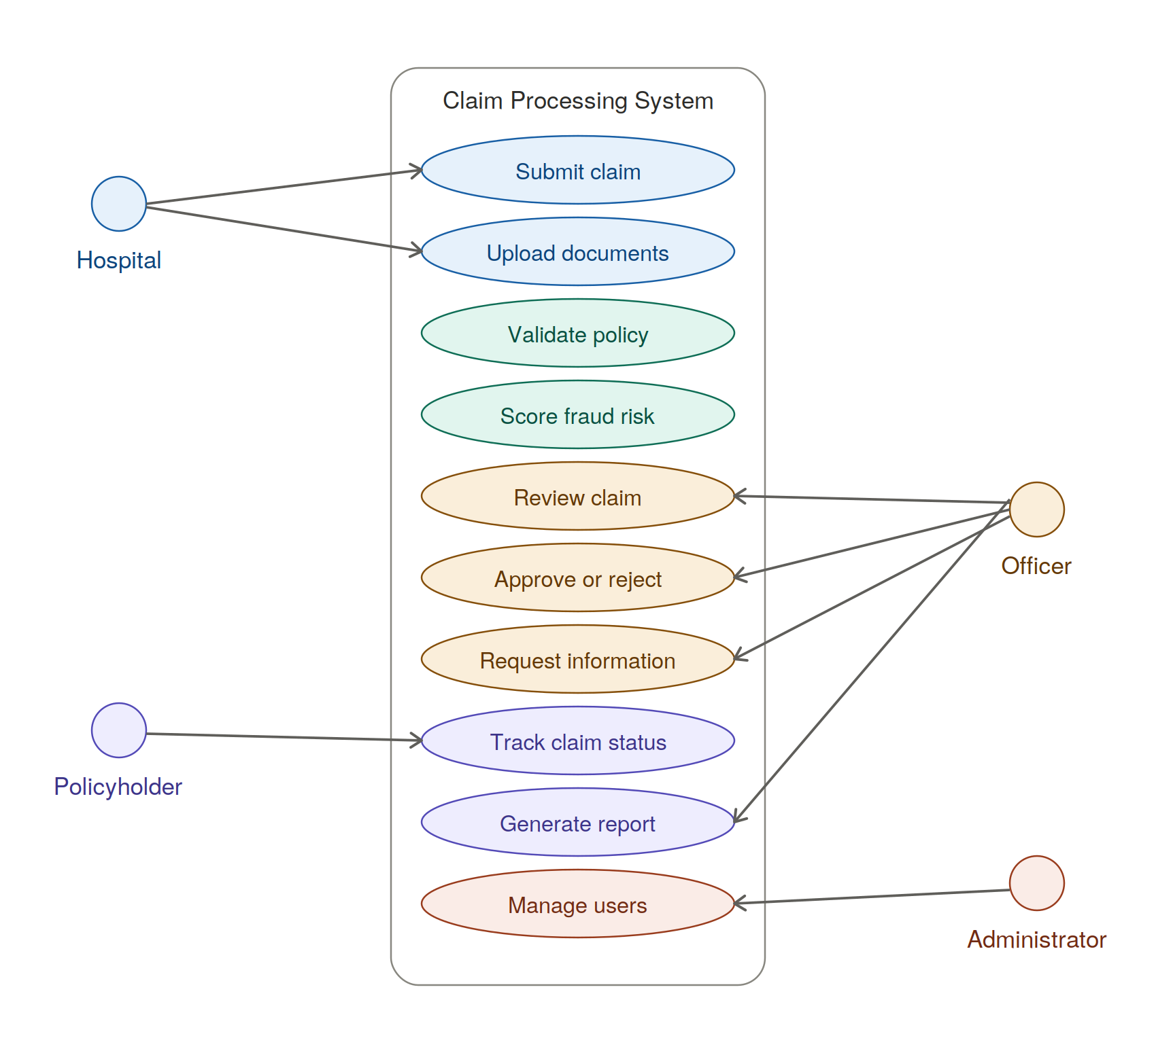
Data Flow Diagrams (DFDs):
Context Diagram (Level 0):
Shows the high-level interaction between hospitals, policyholders, insurance officers, and the Smart Health Insurance Claim Processing and Fraud Detection System. External entities send inputs (claims, documents, decisions) to the single central process and receive outputs (status updates, notifications, reports) in return.

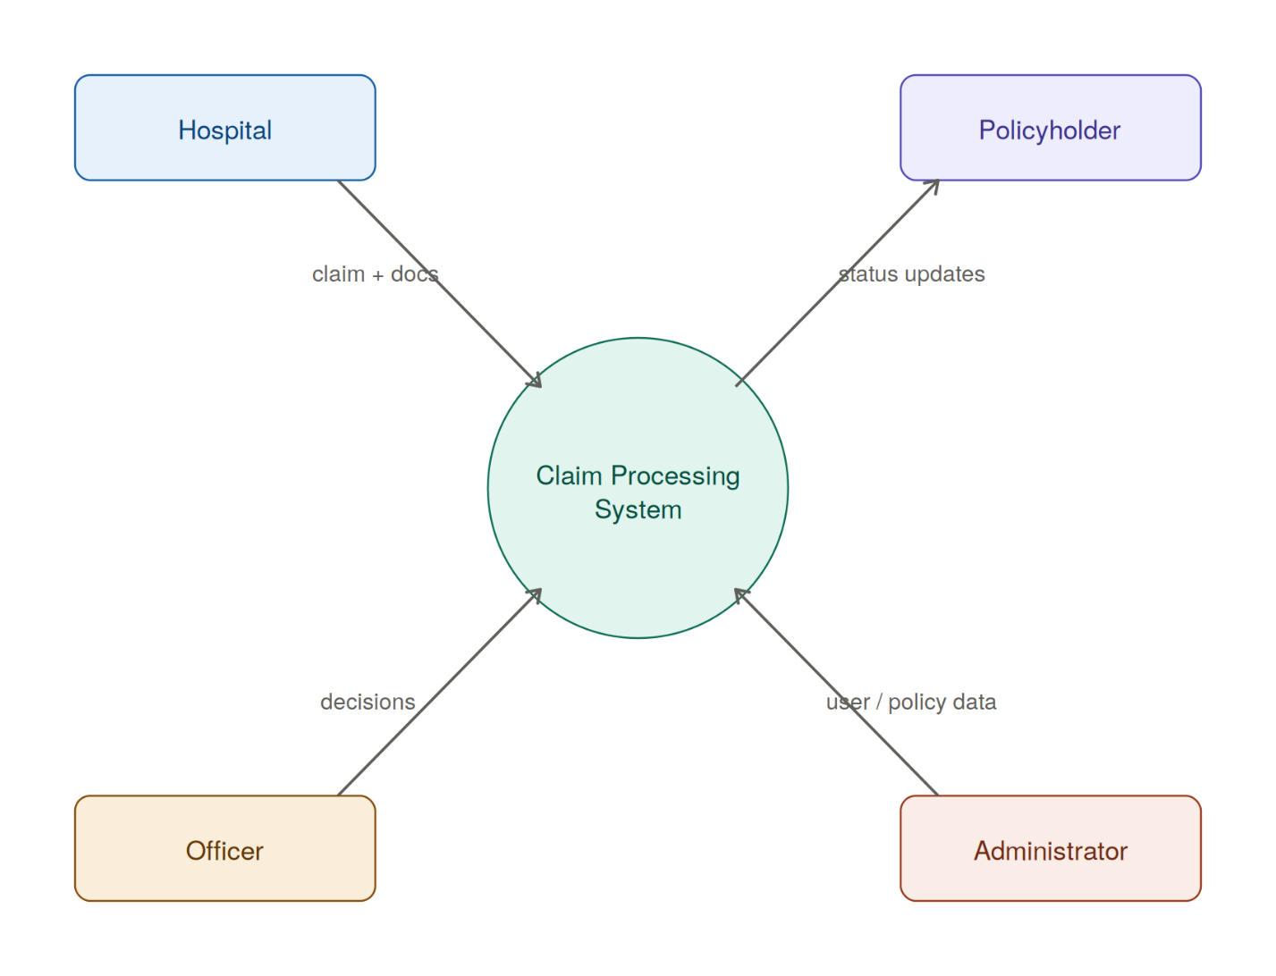

Parent Diagram (Level 1):
Details the major processes:
- Claim Submission
- Policy Validation
- Fraud Risk Scoring
- Claim Approval / Rejection
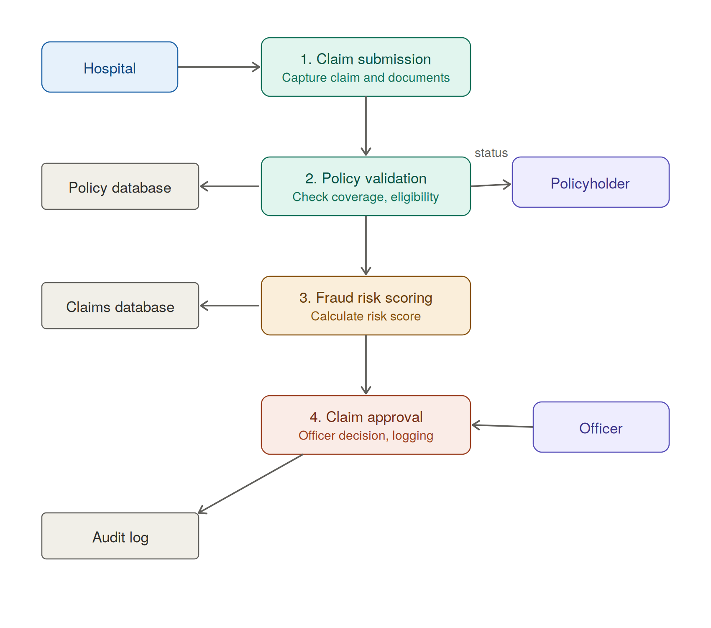
Data stores include: Policy Database, Hospital Database, Claims Database, and Audit Log.

Child Diagrams (Level 2):
Break down each major process into sub-processes:
- Claim Submission → Capture Claim Details, Attach Documents
- Policy Validation → Document Verification, Eligibility Checking
- Fraud Risk Scoring → Risk Score Calculation, Risk Level Assignment
- Claim Approval → Officer Decision, Approval Logging
Suggested Process Model:
Chosen Model: Agile Model
Justification: The Agile model supports iterative development and continuous feedback, which is suitable for systems involving frequent changes in claim validation rules and fraud detection requirements.
Diagram of Phases:
- Requirement Gathering
- Iterative Development and Testing
- Deployment and Feedback
- Final Delivery
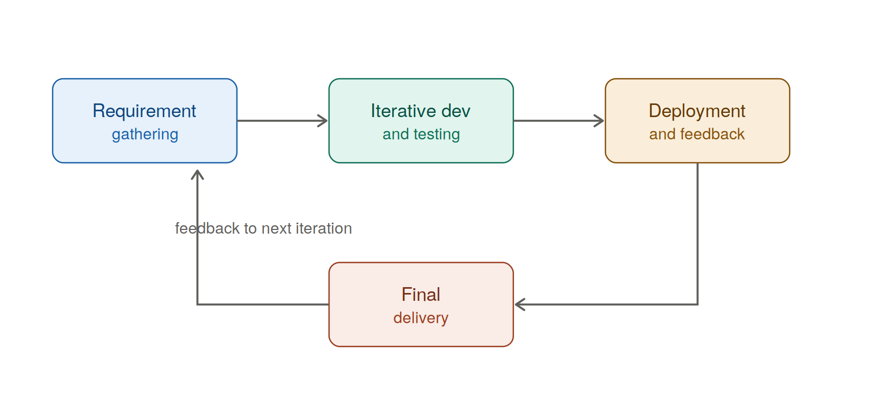

Prototype Screenshots:
The prototype of the Smart Health Insurance Claim Processing and Fraud Detection System was implemented as a Flask-based web application in Python, providing role-based dashboards for hospitals, policyholders, insurance officers, and administrators, with automated policy validation, fraud risk scoring, and a complete claim approval workflow.

Login Screen:
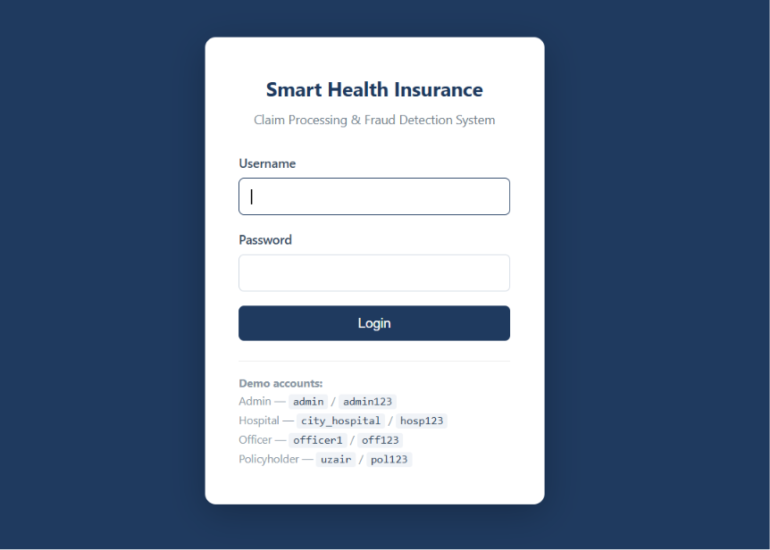

Hospital Dashboard:
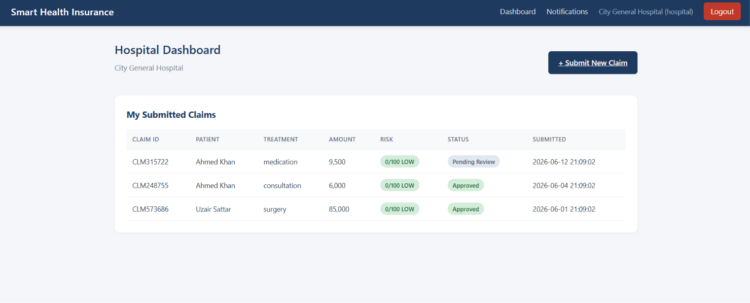
Claim Submission Form:
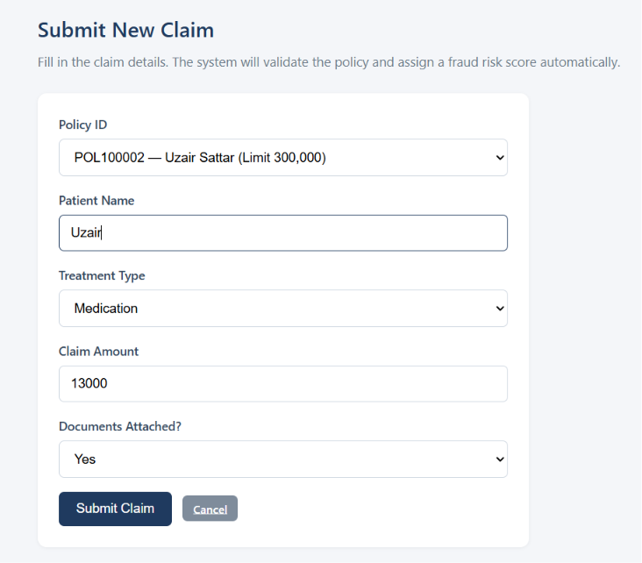
Officer Review Screen:
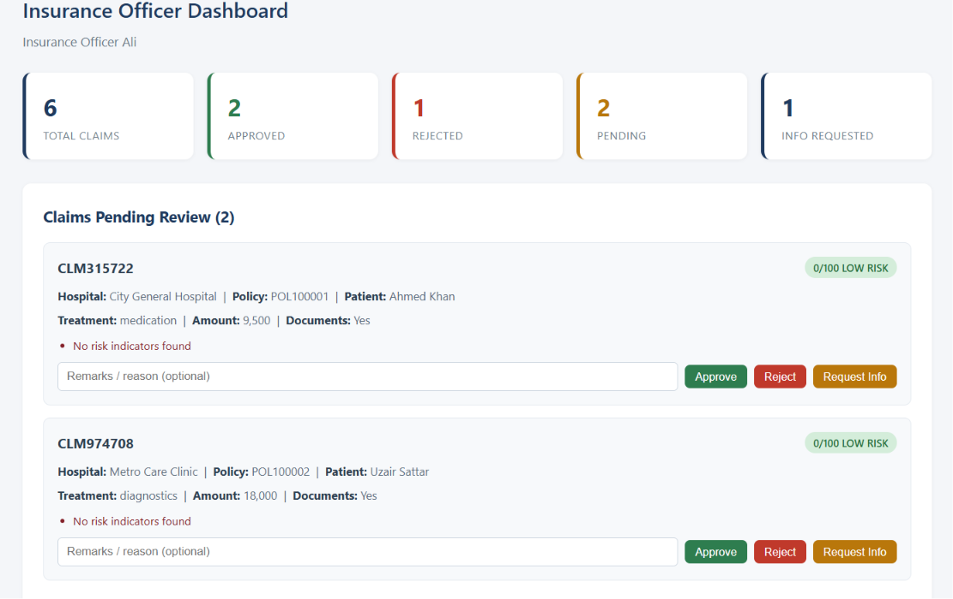
Policyholder Claim Tracking Screen:
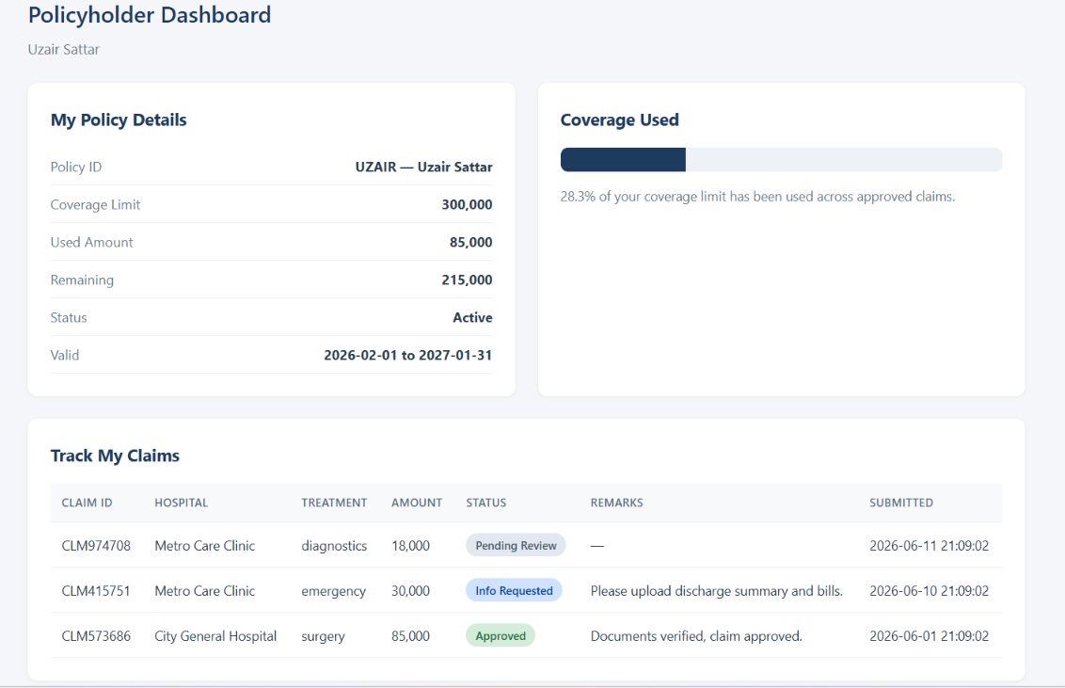
Admin Dashboard :
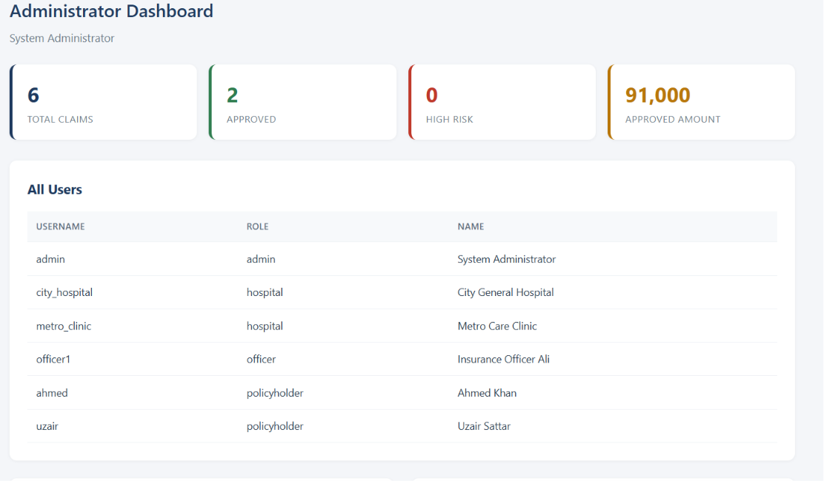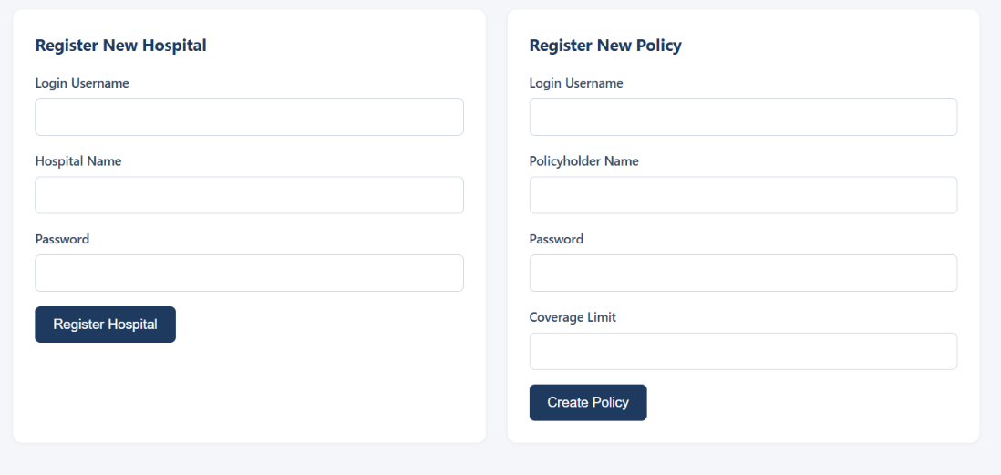

References / Bibliography:
- Sommerville, I. (2016). Software Engineering (10th ed.). Pearson Education.
- Pressman, R. S., & Maxim, B. R. (2020). Software Engineering: A Practitioner's Approach (9th ed.). McGraw-Hill.
- Python Software Foundation. (2024). Python 3 Documentation. https://docs.python.org/3/
- Agile Alliance. (2024). Agile Manifesto and Principles. https://agilemanifesto.org/

